

**International School**

**Software Process & Quality Management**

**CMU-SE 433 SAIS**

**Project Proposal**

**Version 1.1**

**Date: June 12th, 2025**

**Hotel Management System**

**Submitted by**

**Lanh, Do**

**Quyen, Truong Thi My**

**Hoang, Le Huy**

**Quoc, Pham Tan**

**Hung, Duong Van**

**Approved by**

**MSc Huy, Truong Dinh**

**Proposal Review Panel Representative:**

Name Signature Date

**Software Process & Quality Management - Mentor:**

Name Signature Date

**PROJECT INFORMATION**

|  |  |  |  |  |
| --- | --- | --- | --- | --- |
| **Project acronym** | HMS | | | |
| **Project Title** | Hotel Management System | | | |
| **Start Date** | 12 Jun 2025 | | **End Date** | July 23, 2025 |
| **Lead Institution** | International School, Duy Tan University | | | |
| **Project Mentor** | MSc. Duc, Nguyen Manh | | | |
| **Scrum master / Project Leader & contact details** | Lanh, Do  Email: ddolanh0@gmail.com  Tel: 0936212369 | | | |
| **Partner Organization** | Duy Tan University | | | |
| **Project Web URL** |  | | | |
| **Team members** | Name | Email | | Tel |
| 28219129939 | Lanh, Do | ddolanh0@gmail.com | | 0936212369 |
| 28201100757 | Quyen, Truong Thi My | thanhmieu2112@gmail.com | | 0768585726 |
| 28219027592 | Hoang, Le Huy | lehuyhoang123789@gmail.com | | 0935563105 |
| 28212306085 | Quoc, Pham Tan | phamtanquoc1@gmail.com | | 0763739254 |
| 28210201891 | Hung, Duong Van | hd795033@gmail.com | | 0334231904 |

**DOCUMENT APPROVALS**

The following signatures are required for approval of this document.

|  |  |  |
| --- | --- | --- |
| Lanh, Do  Student ID: 28219129939  *Scrum Master* | Signature | Date |
| Quyen, Truong Thi My  Student ID: 28201100757  *Team Member* | Signature | Date |
| Hoang, Le Huy  Student ID: 28219027592  *Team Member* | Signature | Date |
| Quoc, Pham Tan  Student ID: 28212306085  *Team Member* | Signature | Date |
| Hung, Duong Van  Student ID: 28210201891  *Team Member* | Signature | Date |

REVISION HISTORY

| **Version** | **Date** | **Comments** | **Author** |
| --- | --- | --- | --- |
| 1.0 | Jun 12th, 2025 | Initial Release | CMU-SE 433 SAIS.08 Team |
| 1.1 | Jun 15th, 2025 | Update Current Status of Art | CMU-SE 433 SAIS.08 Team |

**TABLE OF CONTENT**

1. Introduction………………………………………………………………………...7

1.1. Purpose Of Document………………………………………………………....7

1.2. Project Goal…………………………………………………………………....7

2. Problem Definition.………………………………………………………………....7

2.1. Business need……………………………...…………………………………...7

2.2. Solution………………………………………………………………………...8

3. Current Status of Art…….……………………………………………………….....9

4. Engineering Approach…………………………………………………………......10

4.1. System context diagram……………………………………………………....10

4.2. System context description……………………………..…………………......10

4.3. Technical Constraints………………..……………………………………......12

5. Tasks and Deliverables………………………………………………….................13

6. Project Management…………………………………………………….……........14

6.1. Cost/Budget for Project……………………………………………….............14

6.2. Tentative Schedule………………………………………………....................15

6.2.1. Master Plan…………………………………………………....................15

6.2.2. Scrum Process………………………………………………...................16

7. Project Constraints………………………………………………..….....................17

8. Conclusion………………………………………………..….................................18

9. References………………………………………………..…………......................18

10. Attachment…………………………………..…………………..….....................18

TABLE OF FIGURES

Firure 1. System context diagram……………………………………………………10

Firure 2. Scrum Process……………………………………………………………...16

**TABLE OF TABLES**

Table 1. Current Status of Art……………………………………………………......9

Table 2. Tasks and Deliverables…………………………………………………….13

Table 3. Cost person/hours………………………………………………………….14

Table 4. Total cost estimation…………………………………………………...…..14

Table 5. Description…………………………………………………………………14

Table 6. Master Plan………………………………………………………………...15

Table 7. Project Constraints…………………………………………………...…….17

1. Introduction

1.1. Purpose of Document

* The document provides an overview of the project includes the purpose and scope of the project.
* Identify business needs, problems or situations related to the initialization and construction projects.
* Provide solutions for business needs and give the overview of system architecture.
* Provide overview about resources, schedule, solution and budget for the project.

1.2. Project Goal

The goal of this hotel management application is to provide an efficient, centralized platform that allows hotels to manage daily operations, including room management, housekeeping, guest services, and financial tracking. The app should streamline hotel processes, reduce manual workloads, and ensure high service quality, thereby increasing overall hotel efficiency and guest satisfaction.

2. Problem Definition

Hotels: Hotels often face challenges in managing internal operations such as room availability, booking synchronization with external platforms (OTAs), housekeeping tasks, guest service requests, and financial tracking. These tasks are typically handled manually or across different disconnected systems, which leads to inefficiencies, delays, and increased risk of errors. Poor communication between departments (front desk, housekeeping, maintenance) can lead to unsatisfactory guest experiences and operational bottlenecks.

Hotel Owners: Lack of accurate and timely information about room status, services, and customer requests makes it difficult to make informed management decisions and predict business demand.

2.1. Business need

- Centralized Management: A single system that integrates room availability, housekeeping, guest requests, and billing in one place.

- Efficiency in Operations: Reduce manual efforts for managing bookings, scheduling housekeeping, tracking maintenance, and processing payments.

- Improved Guest Service: Provide faster and more reliable service to guests by improving communication and tracking between staff.

- Real-time Data & Analytics: Access up-to-date information on room occupancy, guest preferences, and financial performance, enabling better decision-making.

- Integration with OTAs: Synchronize room availability and pricing across online booking platforms to avoid overbooking or underutilization of rooms.

2.2. Solution

The solution involves developing a comprehensive hotel management application designed to streamline and automate internal hotel operations. This application will offer centralized room and booking management, enabling staff to handle room availability, allocate bookings, and track room statuses in real-time. It will include features for automating housekeeping and maintenance tasks, ensuring timely and efficient service while maintaining room quality. The system will manage guest service requests, facilitate billing and payments, and generate real-time reports on occupancy, revenue, and guest feedback. Integration with online travel agencies (OTAs) will synchronize room availability and pricing, reducing the risk of overbooking and optimizing revenue. Additionally, the application will provide financial tracking and business insights, equipping hotel owners with the tools needed for data-driven decision-making and dynamic pricing to enhance overall profitability.

3. Current Status of Art

Table 1. *Current Status of Art*

|  |  |  |  |
| --- | --- | --- | --- |
| **Feature** | **Cloudbeds** | **Little Hotelier** | **Hostelworld** |
| **Room Management** | **X** | **X** | **X** |
| **Real-time Room Status** | **X** | **X** | **X** |
| **Online Booking** | **X** | **X** | **X** |
| **OTA Channel Integration (Booking, Agoda, etc.)** | **X** | **X** | **X** |
| **Customer Service Management** | **X** | **X** | **X** |
| **Financial Management** | **X** | **X** | **X** |
| **Invoice and Payment Tracking** | **X** | **X** | **X** |
| **Revenue Reporting & Analysis** | **X** | **X** | **X** |
| **Demand Forecasting** | **X** |  |  |
| **Loyalty Program Integration** | **X** |  |  |
| **Promotional Program Management** | **X** |  |  |

**Our website overcomes disadvantages that competitors inconvenience users such as:**

* Provide advanced tools for demand forecasting, dynamic pricing adjustments, and revenue optimization based on occupancy rates, seasonality, and local events.
* Develop a CRM system that leverages guest data to provide personalized experiences—such as recognizing returning customers, remembering preferences, and offering targeted promotions and loyalty programs.

4. Engineering Approach

**4.1**. **System context diagram**

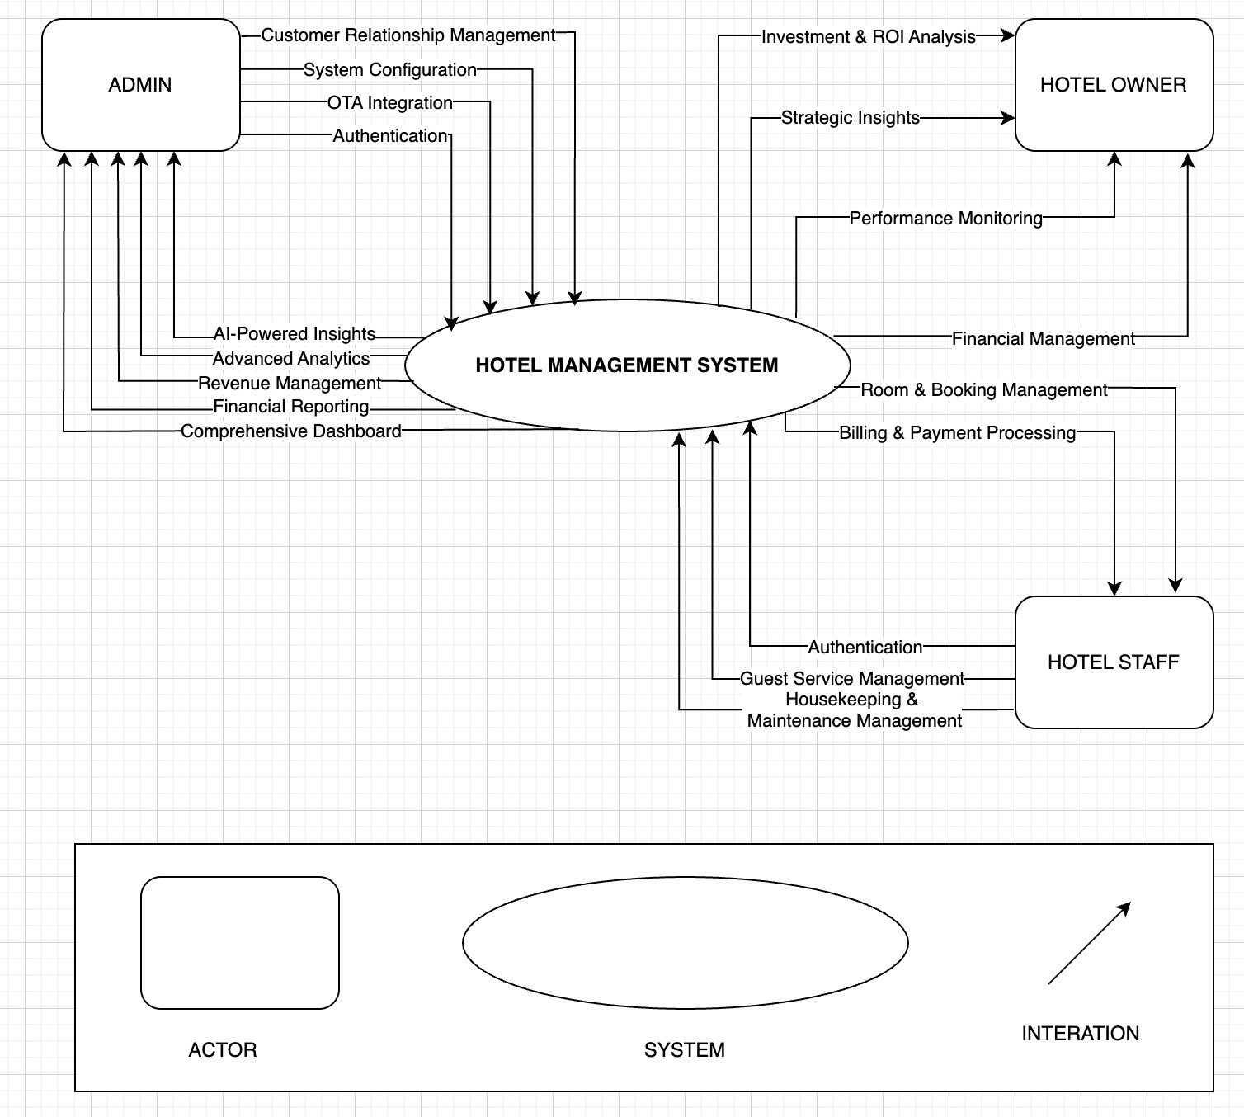

**Firure 1.** *System context diagram*

4.2. System context description

**- Admin:**

* Admin can manage authenticate identity (login/logout)
* Admin can view summarized information on hotel operations, helping management quickly grasp the overall situation for more effective decision-making.
* Admin can view reports on revenue, expenses, and profits to assist management in making accurate financial decisions.
* Admin can track historical room price adjustments and monitor revenue forecasts based on past data.
* Admin can monitor user permissions and system settings to ensure they align with the hotel's requirements.
* Admin can monitor the process of synchronizing room availability and pricing with online travel agencies.
* Admin can view market and competitor analysis reports to support strategic planning.
* Admin can view reports on booking trend forecasts and price adjustments to optimize revenue strategies.
* Admin can monitor and view reports analyzing customer data to support effective marketing campaigns.

- **Hotel Staff:**

* Hotel staff can authenticate identity (login/logout)
* Hotel staff can manage room check-ins/check-outs and updates room status.
* Hotel staff can generate invoices, process payments, handle billing adjustments and access payment history and generate receipts for guests.
* Hotel staff can handle service requests (room service, laundry, repairs) efficiently and update guests on the status of their requests and ensure timely service.
* Hotel staff can track housekeeping tasks, assign responsibilities, and monitor completion and manage maintenance requests, schedule repairs, and track issue resolution.

**- Hotel Owner:**

* Hotel owner can access to comprehensive financial reports and performance dashboards.
* Hotel owner can track key performance indicators (KPIs) like RevPAR (Revenue per Available Room) and ADR (Average Daily Rate) and monitor operational efficiency and guest satisfaction metrics.
* Hotel owner can analyze market trends and competitive positioning and access predictive analytics for revenue forecasting and strategic planning.
* Hotel owner can assess the return on investment (ROI) of various operational changes and improvements and comparative analysis of different revenue strategies and their impact on profitability.

4.3. Technical Constraints

**Technical to develop:**

* Programming language: JavaScript, python,
* Library: Hook, Redux, React hook form, Font awesome, Material UI, Express.js, TensorFlow.js, Socket.io, JWT,
* Technology: Reactjs, Nodejs, Redis, WebSocket, Data Training and Machine Learning
* Database: SQL Server.
* Version Control System: GitHub
* Team Management: Trello, Zalo, Google drive
* Develop tools: Visual Studio Code

**Environments:**

* Internet Connection
* Operation System: Google Chrome, Microsoft Edge, CocCoc, Firefox
* Other Constraints:
* Resource: 5 people.
* Budget: Limited.
* Time: The project must be completed within 1 and a half months.
* These features are not available in the first version of the product.

5. Tasks and Deliverables

**Table 2.** *Tasks and Deliverables*

|  |  |  |
| --- | --- | --- |
| **No.** | **Task name** | **Description** |
| **1.** | **Start up** |  |
| 1.1 | Project kick off meeting | Encountering the developer team and stakeholder to clear out the goal, defining of the base elements for the project and other project planning activities |
| 1.2 | Discuss about project | Brighten up the current ideal to both developer  team and stakeholder |
| 1.3 | Create Document | Release the artifacts or schematics related to project to product owner, include Proposal, User story, Product backlog, Project plan… |
| **2.** | **Development** |  |
| 2.1 | Sprint Planning | A Sprint begins with a sprint planning session that sets goals and plans details for the work to be done |
| 2.2 | Sprint 1 | Release the first look of the product (ver1.0) with functions which have been committed in the contract |
| 2.3 | Sprint 2 | Release the update for ver1.0 (ver1.1) with functions which have been approved by product owner |
| 2.4 | Sprint 3 | The next update (ver1.2) for previous phase |
| **3.** | **Project ‘s meeting** | Private meeting between members to make plan what will be presented to customer in the final release |
| **4.** | **Final Release** | Release the final version to product owner with complete function |

6. Project Management

6.1. Cost/Budget for Project

**Table 3*.*** *Cost person/hours*

|  |  |  |
| --- | --- | --- |
| **Full Name** | **Role** | **Salary Rate (USD/hour)** |
| Lanh, Do | Scrum Master | 2 |
| Quyen, Truong Thi My | Team Member | 2 |
| Hoang, Le Huy | Team Member | 2 |
| Quoc, Pham Tan | Team Member | 2 |
| Hung, Duong Van | Team Member | 2 |

**Table 4.***Total cost estimation*

|  |  |  |  |
| --- | --- | --- | --- |
| **No** | **Criteria** | **Price** | **Total (USD)** |
| 1 | Working hours | 5 | 780 |
| 2 | Other cost | 100 | 500 |
|  |  |  | 1280 |

**Table 5*.*** *Description*

|  |  |  |
| --- | --- | --- |
| **Description** | **Amount** | **Unit** |
| Number of members | 5 | Person |
| Number of working hours per day | 2 | Hours |
| The cost per hour per member | 5 | USD |
| The number of working days | 42 | Days |

**-** The explanation for the table

* Amount of working hours = 5 members * 2 hours * 42 days
* Other cost = 5 members * 100 USD

6.2. Tentative Schedule

6.2.1. Master Plan

Table 6. *Master Plan*

|  |  |  |  |  |
| --- | --- | --- | --- | --- |
| **NO** | **Task Name** | **Duration** | **Start** | **Finish** |
| **1.** | **Initial** | **6 days** | **June 12, 2025** | **June 17, 2025** |
| 1.1 | Gathering Requirement | 3 days | June 12, 2025 | June 14, 2025 |
| 1.2 | Create Proposal Document | 3 days | June 15, 2025 | June 17, 2025 |
| **2** | **Start Up** | **6 days** | **June 18, 2025** | **June 23, 2025** |
| 2.1 | Project Kick-off Meeting | 2 days | June 18, 2025 | June 19, 2025 |
| 2.2 | Create Document | 4 days | June 20, 2025 | June 23, 2025 |
| **3** | **Development** | **25 days** | **June 24, 2025** | **July 18, 2025** |
| 3.1 | Sprint 1 | 9 days | June 24, 2025 | July 2, 2025 |
| 3.2 | Sprint 2 | 11 days | July 3, 2025 | July 13, 2025 |
| 3.3 | Sprint 3 | 5 days | July 14, 2025 | July 18, 2025 |
| **4** | **Project’s Retrospective Meeting** | **04 days** | **July 19, 2025** | **July 22, 2025** |
| **5** | **Final Release** | **01 days** | **July 23, 2025** | **July 23, 2025** |

6.2.2. Scrum Process

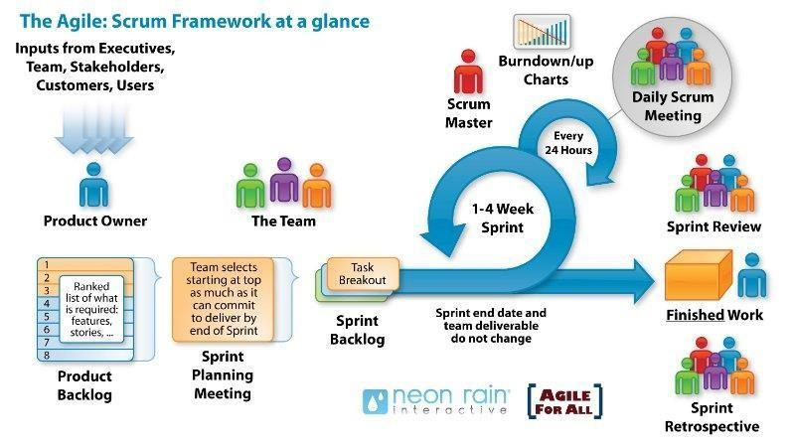 **Firure 2.** *Scrum Process*

* Scrum is an iterative and incremental agile software development framework for
* managing software projects and product or application development.
* Scrum focuses on project management institutions where it is difficult to plan ahead.
* Mechanisms of empirical process control, where feedback loops that constitute
* the core management technique is used as opposed to traditional command-and
* -control management.
* Its approach to planning and managing projects is by bringing decision-making
* authority to the level of operation properties and certainties.
* Benefit of the methodology:
  + - Project can respond easily to change.
    - Problems are identified early.
    - Customers get the most beneficial work first.
    - Work done will better meet the customer’s needs.
    - Improved productivity.
    - Ability to maintain a predictable schedule for delivery.

7. Project Constraints

Table 7. *Project Constraints*

|  |  |  |
| --- | --- | --- |
| **Constraint** | **Constraints Description** | **Guidelines for Acceptance** |
| **Economic** | In terms of cost, the main issue lies in the cost of researching, implementing a backend to handle, and analyze data, and front end with a user-friendly interface. There is also the cost of renting a server and deploying a server. | Design cost: 200-300$, Production cost: 4500-500$, Maintenance cost: 400-500$, Operating costs :450-600$ Sales price: 9000-10000$ |
| **Environmental** | The system does not affect the environment. | No impact on the environment. |
| **Ethical** | - Ensure that the system protects user data and privacy. The system should be reliable and accurate in sending SOS signals and communicating with rescue stations. False alarms should be minimized | Ethical considerations can be broad. Areas that are typically addressed include intellectual property, reverse- engineering, privacy, security. |
| **Public health, safety, and welfare** | Safe and does not adversely affect users. | Includes safety standards as well as impact of the design on users (for example, electrical or physical hazards) |
| **Social and Global** | This software is for students. This application is essential for monitoring students' psychology to provide solutions to help them relax more to focus on their studies and get good results. | The product needs to be developed in an optimal and user-friendly way to reach the closest to students. |
| **Cultural** | The application is suitable for all Vietnamese students. | Which cultural characteristics could influence the approach?  How do the design from different cultures differ? |
| **Sustainability** | It is necessary to maintain the continuous operation of the system, so as not to affect the visualization and analysis of human psychology. | Refers to sustainability involves ensuring resources like materials, energy, and supplies, as well as manufacturing techniques, personnel, operations, and infrastructure, are used efficiently. It also includes designing for reliability, longevity, durability, reusability, and maintainability. |

8. Conclusion

The hotel management project aims to develop a comprehensive system to efficiently and conveniently manage hotel operations. This system includes key functions such as booking management, customer management, financial management, and employee management. Customers can easily book rooms online, check room availability, and make payments through the system. Hotel management can quickly and accurately track and update information on rooms, services, and staff. The system also provides detailed financial reports and performance analysis, helping management make informed business decisions. Implementing technology in hotel management not only saves time and effort but also enhances service quality and customer experience.

The project team will develop the system over 16 weeks with a budget of $5600 for four members. We ensure to comply with schedules, budgets, and deliver products on time. We are determined to agree together, unite, research solutions to overcome challenges and manage progress to bring the project to success.

9. References

**[1]. Software Development Standards for the Guidance and Control Software Project**

[***https://sw-eng.larc.nasa.gov***](https://sw-eng.larc.nasa.gov)

**[2]. General Software Coding Standards and Guidelines** [***https://www.nws.noaa.gov/oh/hrl/developers_docs/General_Software_Standards.pdf***](https://www.nws.noaa.gov/oh/hrl/developers_docs/General_Software_Standards.pdf)

**[3]. Scrum and best practices**

***https://docs.microsoft.com/en- us/azure/devops/boards/sprints/best-practices-scrum?view=azure-devops***

**[4]. The Scrum Guide**

[***https://www.scrum.org/resources/scrum-guide***](https://www.scrum.org/resources/scrum-guide)

**[5]. The ISO/IEC & IEEE/EIA Standard 12207, IEEE standards: IEEE-829 [3],**

**IEEE-1008 [5], IEEE-1012**

**[6] React documentation**

[**https://reactjs.org/docs/getting-started.html**](https://reactjs.org/docs/getting-started.html)

**10. Attachment**